Social Support Workflow Automation System

1. Introduction
This document outlines the end-to-end solution architecture for automating the Social Support Application Workflow using Agentic AI, Machine Learning, and Local LLM. The goal is to demonstrate how intelligent automation can reduce manual effort, increase consistency, and deliver decisions in minutes instead of weeks.

2. Current System (Problem Statement)
- Slow Process: Applications take 5–20 working days due to manual data handling, lengthy reviews, and inconsistent information.
- Key Issues: Manual data gathering, semi-automated validations, inconsistent form data, time-consuming reviews, and subjective decisions.

3. Overview of the Solution
The proposed AI-driven workflow automates the eligibility evaluation and recommendation process for social support applications.
- Objective: Achieve up to 99% automation for high-confidence cases within minutes.
- Impact: Improve efficiency, transparency, and citizen satisfaction by eliminating manual dependency.

4. Assumptions & Constraints
- Automation Scope: Focuses on fully automating high-confidence ML cases. Human-in-the-loop processing is excluded due to time constraints.
- Hosting Environment: Prototype runs locally using Docker, easily portable to Azure Cloud for production.
- Compute & Model Limitations: Local CPU/GPU resources limit LLM and ML inference speed and concurrency.
- Integration Scope: Gov Identity / Emirates ID, Credit Bureau integrations and others are mocked for prototype demonstration.
5. Application Architecture
5.1 Architecture Overview
The system automates the end-to-end social support workflow using Agentic AI orchestration and Machine Learning algorithms.
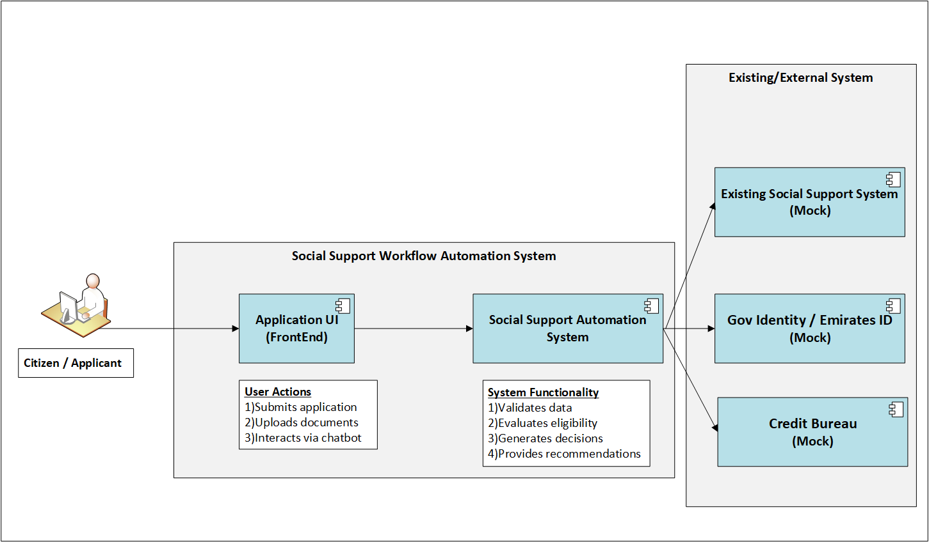
Fig 1: Social Support Workflow Automation System

Applicants interact through a Streamlit - Application UI that collects structured/unstructured data and attachments (e.g., bank statements, ID scans, resumes, credit reports).
The backend orchestrates multi-step AI agents to extract, validate, and score data, generating eligibility and recommendations in real-time.

5.2 High-Level Application Architecture
The system integrates a Streamlit Chat UI, FastAPI Orchestrator, AI Agents, and LLM models within a unified architecture, enabling intelligent automation and decision-making, while a secure data storage and pipeline layer manages all data flow and integrations.

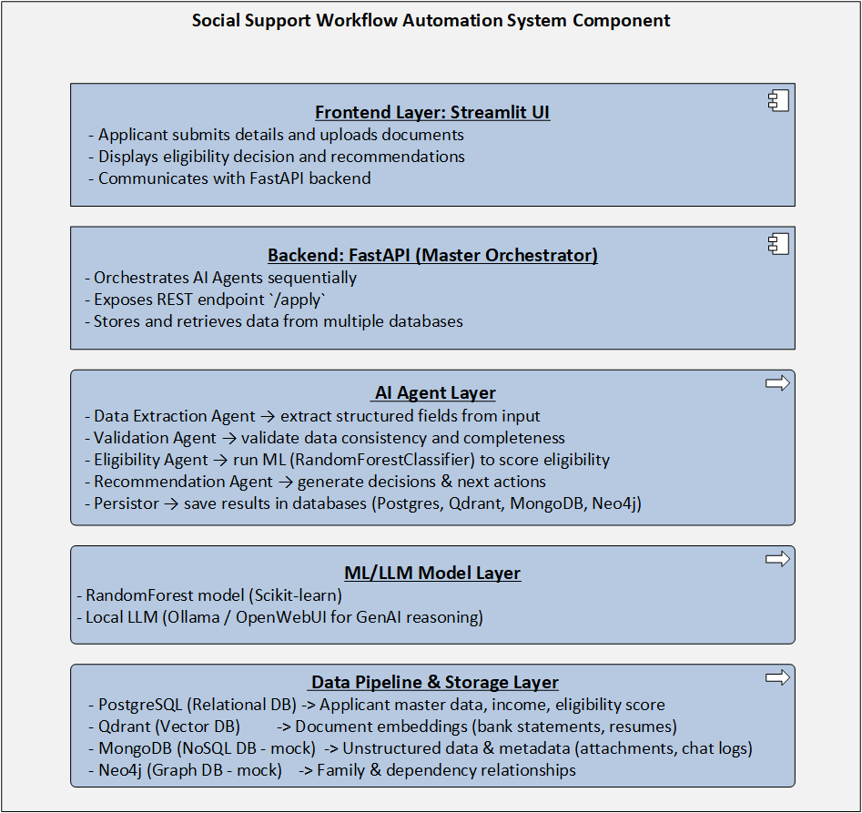
Fig 2: Social Support Workflow Automation System Component

Frontend Layer – Streamlit Chat UI
- Collect applicant details and document uploads.
- Displays eligibility decision and recommendations.
- Communicates with backend REST APIs.

Backend Layer – FastAPI (Master Orchestrator)
- Acts as central controller managing all agents.
- Exposes /apply endpoint.
- Maintains conversational state and agent memory across steps.

AI Agent Layer
- Data Extraction Agent: Extracts structured data from uploaded PDFs, images, and Excel sheets using OCR/Tabular parsers.
- Validation Agent: Validates data for completeness, consistency, and logical accuracy.
- Eligibility Agent: Runs ML model (RandomForestClassifier) to predict applicant eligibility.
- Recommendation Agent: Uses LLM reasoning to generate decision explanation and next steps.
- Persistor: Stores outcomes into respective databases.
ML/LLM Model Layer
- ML Model: RandomForestClassifier (Scikit-learn) for tabular eligibility prediction.
- LLM: Ollama / OpenWebUI for local reasoning and explainability.
Data Storage & Pipeline Layer
- PostgreSQL: Relational structured applicant and scoring data.
- Qdrant: Vector embeddings from text-based documents for semantic retrieval.
- MongoDB (mock): Stores attachments metadata, chat logs, and unstructured data.
- Neo4j (mock): Models family/dependency graph relations for richer contextual reasoning.

6. Application Components
System Workflow
The social support workflow automation system begins with the Applicant, who accesses the Chat-based User Interface (UI) to submit their application details and upload supporting documents such as Emirates ID, bank statements, credit reports, and financial summaries.
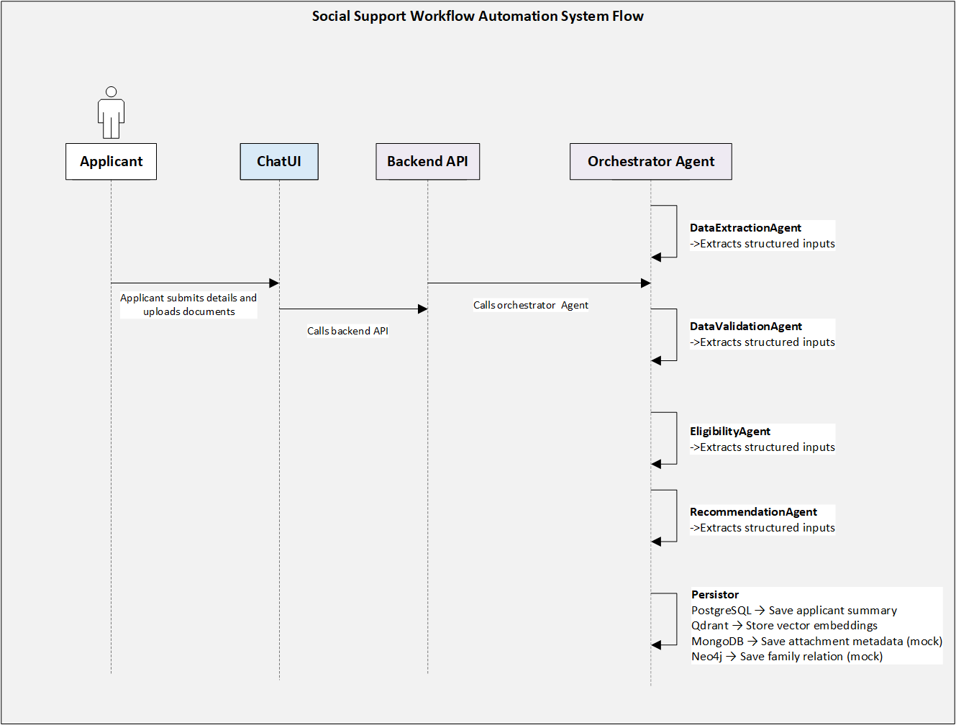
Fig 3: Social Support Workflow Automation System Flow

The ChatUI communicates with the FastAPI backend, which serves as the Master Orchestrator. The orchestrator manages the overall workflow, invoking each AI Agent sequentially while maintaining a shared state across them to ensure consistent processing and context retention.
The first agent in the workflow is the Data Extraction Agent, which extracts structured information from uploaded documents using OCR and document parsing logic. Once the data is structured, the Data Validation Agent checks for completeness, consistency, and logical accuracy (e.g., matching income details across multiple documents).
After validation, the Eligibility Agent applies a trained RandomForestClassifier ML model to score and classify applicant eligibility for social or economic support programs. Based on the eligibility score and predefined thresholds, the Recommendation Agent generates automated recommendations or decisions, suggesting whether the applicant qualifies for support and potential enablement actions such as job placement or training.

Once the decision and recommendations are generated, the Persistor component stores the results across multiple databases:
- PostgreSQL holds core applicant and eligibility data.
- Qdrant stores vector embeddings for unstructured document search and similarity queries.
- MongoDB (mock) keeps attachment metadata and chat interactions.
- Neo4j (mock) model applicant family or dependency relationships.
This end-to-end system delivers an efficient, scalable, and explainable automation pipeline, capable of processing most applications autonomously within minutes while maintaining compliance, transparency, and data governance standards.

7. Technology Stack
The following table outlines the selected tools and the rationale for their use.
Category | Technology / Tool | Justification
Programming Language | Python | Industry-standard for AI/ML; mature ecosystem (Scikit-learn, LangChain, LangGraph). Compared to Node.js or Java, it offers richer ML tooling and faster experimentation.
Frontend | Streamlit | Enables rapid UI development for POC AI apps; lightweight and supports real-time updates. Compared to React or Flask UI, it requires minimal code for data interaction and visualization.
Backend | FastAPI | High-performance async API framework with automatic validation and OpenAPI docs. Faster and more efficient than Flask or Django for microservices.
Agent Framework | LangGraph | Provides composable, stateful, and memory-aware orchestration for multi-agent workflows. More maintainable and structured than ReAct-only or CrewAI setups.
ML Library | Scikit-learn (RandomForestClassifier) | Robust for tabular classification, interpretable, and low latency. Easier to explain and deploy than deep learning models for structured data.
LLM Hosting | Ollama / OpenWebUI | Local inference ensures privacy and compliance. Faster inference for small models vs. remote APIs (like OpenAI or Anthropic).
Relational DB | PostgreSQL | Proven enterprise-grade RDBMS, ACID-compliant, scalable, and secure. Preferred over MySQL for JSONB support and analytical extensions.
Vector DB | Qdrant | Optimized for high-performance semantic search; supports hybrid filtering. Easier to deploy and lighter than Pinecone or Weaviate for local setups.
NoSQL DB (Mock) | MongoDB | Flexible schema and unstructured storage; ideal for mock prototyping vs. CouchDB or DynamoDB.
Graph DB (Mock) | Neo4j | Excellent for modeling relationships; offers Cypher query language and built-in visualization. Superior to generic NoSQL for graph-based reasoning.
Containerization | Docker | Enables environment isolation, reproducibility, and seamless migration to cloud. Simpler than Kubernetes for prototype deployment.
Observability | LangFuse | Provides LLM prompt, latency, and trace observability. More specialized for GenAI than generic APM tools like Datadog or New Relic.
Version Control | GitHub | Cloud-based repository for code and documentation with CI/CD hooks.
Mock Services | Gov Identity / Credit Bureau APIs (Simulated) /Other Mocks | Simulate real-world ID validation and credit scoring for testing. Reduces dependency risk and allows performance tuning before live integration.
Cloud Readiness | Azure Cloud (future state architecture included below) | Supports scaling with Azure ML, Azure AI Foundry, and managed vector databases for production.

8. Non-Functional Requirements (NFR)
Scalability & High Availability
- Stateless backend supports horizontal scaling.
- Each database or model container can be scaled independently.
- Designed for eventual deployment on Azure with container orchestration.
Observability, Explainability & Governance
- Langfuse tracks agent reasoning and latency.
- ML models log feature importance for transparency.
- All agent and model interactions are auditable.
- Local LLM hosting ensures data sovereignty.
Security & Compliance (During Cloud Implementation)
- Encrypted communication (HTTPS/TLS).
- Follows government data protection and ISO 27001 compliance.

9. Future Improvements
- Integrate with existing system and external system (real-time credit bureau and government ID) for data sources to enable live verification.
- Add human-in-the-loop for low-confidence or ambiguous ML decisions.
- Migrate to Azure AI Foundry and Azure ML for model lifecycle management.
- Secure real-time integrations with Government Identity (Emirates ID) and Credit Bureau APIs replace mock services, ensuring accurate applicant data validation.
- AI pipeline leverages Azure AI Search and Azure OpenAI (RAG) for context-grounded reasoning on applicant documents.
- All components are containerized and deployed on Azure Kubernetes Service (AKS), supported by Azure Blob Storage, Key Vault, Azure Monitor, and Azure AD for secure, observable, and scalable operations.
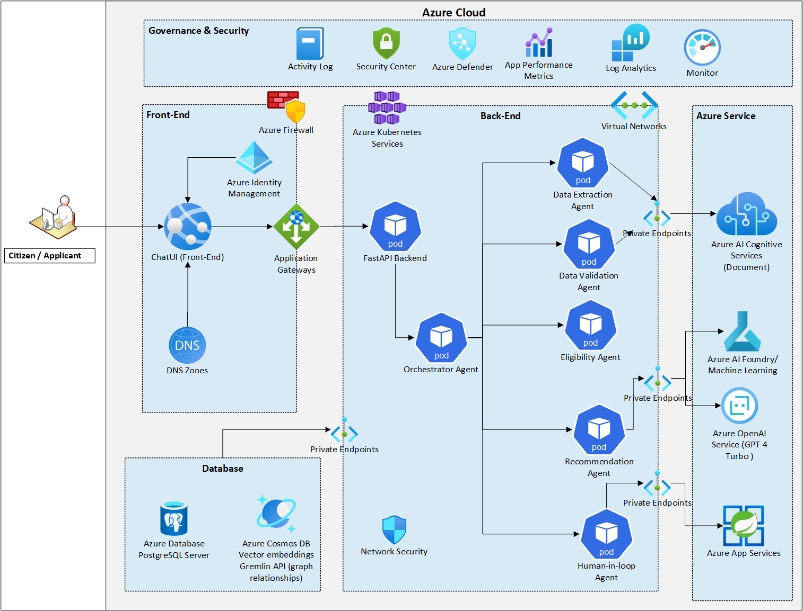
Fig 4: Future State - Social Support Workflow Automation System

